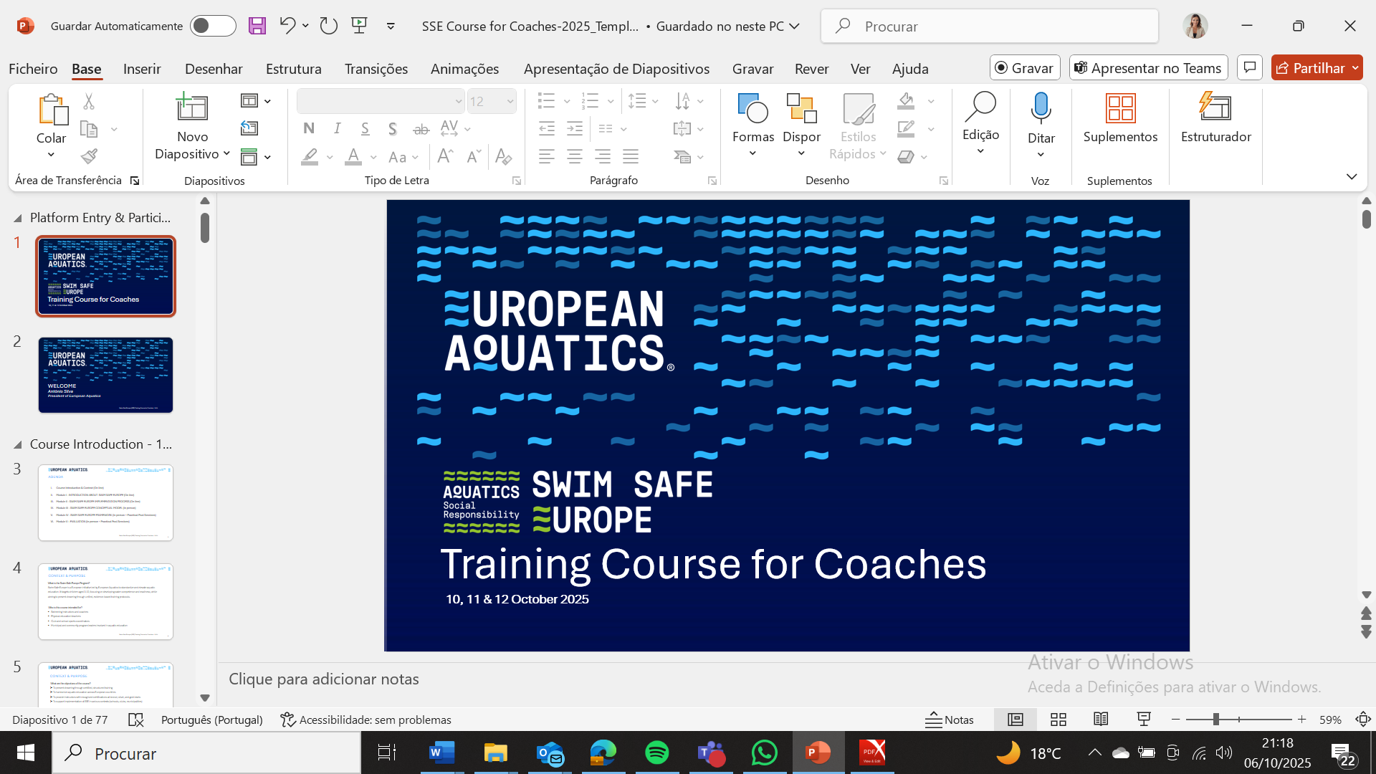

SSE Training Course – Online & In-Person Sessions
• Friday, 10 October 2025 (10h00 – 14h00) – Online
• Saturday & Sunday, 11–12 October 2025 (09h00 – 12h30 | 14h00 – 18h30) – In-Person

Faculty
- Antonio Silva, PhD – Professor, University of Trás-os-Montes & Alto Douro, Vila Real; President, European Aquatics; Vice President, World Aquatics
- Aldo Costa, PhD – Professor, University of Beira Interior; President, Portuguese Swimming Coaches Association; Vice President, Coaching Confederation of Portugal
- Sílvia Costa – PhD Student; Project Manager, ASR European Aquatics
- Boro Strumbelj – Professor, University of Ljubljana
- Rókur í Jákupsstovu – Bureau Member, European Aquatics; President, Faroe Islands Aquatics; AQUA Certified Level 3 Coach

PROGRAMME

Friday, 10 October 2025 – Online Session (10h00–14h00)
Time | Activity | Description | Speaker
10:00 – 10:15 | Platform Entry & Participant Reception | —
10:15 – 10:30 | Welcome & Introduction | Opening remarks and overview of the course structure. | Antonio Silva
10:30 – 11:15 | Module I: Introduction to SSE | Overview and context of the SSE framework, based on the 2023 LTS presentation and survey results. | Aldo Costa
11:15 – 11:30 | Q&A – Module I | Open floor for participant questions. | Aldo Costa
11:30 – 11:45 | Coffee Break | —
12:00 – 12:45 | Module II: Implementation Process | Explanation of the SSE implementation process, with a brief preview of Module III | Sílvia Costa
12:45 – 13:00 | Q&A – Module II | Open floor for participant questions. | Sílvia Costa
13:00 – 14:00 | Knowledge Assessment Test | Online test to assess knowledge acquired during the session (form available).

Saturday, 11 October 2025 – Day 1 (09h00–12h30 | 14h00–18h30)
Time | Activity | Description | Speaker
09:00 – 10:30 | Module III | Concepts about Aquatic readiness and Water competence | Boro Strumbelj
10:30 – 10:45 | Coffee Break | —
10:45 – 12:30 | Module III & Module IV (Introduction) | Transition to Module IV content. | Boro Strumbelj
12:30 – 14:00 | Lunch Break | —
14:00 – 16:00 | Module IV – Bronze, Silver and Gold Levels | Teoretical Part | Rókur í Jákupsstovu
16:00 – 16:30 | Coffee Break & Transfer to Pool Session | —
16:30 – 18:30 | Pool Session – Bronze, Silver and Level | Practical application session at the pool. | Rókur í Jákupsstovu & Boro Strumbelj

Sunday, 12 October 2025 – Day 2 (09h00–12h30 | 14h00–18h30)
Time | Activity | Description | Speaker
09:00 – 10:30 | Module IV – Bronze, Silver, Gold Level | Hand on session: Design pratical learning tasks adapted to each level. | Boro Strumbelj & Rókur í Jákupsstovu
10:30 – 10:45 | Coffee Break | —
10:45 – 12:30 | Module IV – Bronze, Silver, Gold Level | Hand on session: Design and deliver pratical learning tasks adapted to each level. | Boro Strumbelj & Rókur í Jákupsstovu
12:30 – 14:00 | Lunch Break | —
14:00 – 16:00 | Brain Storm and Evaluation | Final Discussion Ainda estou na reunião | Rókur í Jákupsstovu & Boro Strumbelj
16:00 – 16:30 | Coffee Break & Transfer to Pool Session | —
16:30 – 18:30 | Pool Session | Practical session in the pool. Deliver pratical learning tasks adapted to each level and aply efective instrutional strategies. | Rókur í Jákupsstovu & Boro Strumbelj

